**Topcoder - Elasticsearch Feeder Service For Challenges version 1.0**

**Verification Guide**

# 

# Setup

For the challenge feeder service, run 'mvn clean package' to compile the code and then cd local folder and run './run.sh' to start the services. Before starting the services, you need to first setup the envrionment as following sections.

If you want to push the challenge to the amazon elasticsearch service, configure the

the local/run.sh as:

#export ELASTIC_SEARCH_URL="http://$DOCKER_IP:9200"

export ELASTIC_SEARCH_URL="https://search-your-url-xxxxx.us-east-1.es.amazonaws.com"

export CHALLENGES_INDEX_NAME="challenges"

export AWS_SIGNING_ENABLED=false

export AWS_REGION=us-east-1

export ASW_SERVICE=es

export AWS_ACCESS_KEY=your key here

export AWS_SECRET_KEY=your secret here

You should create the domain at https://aws.amazon.com/cn/elasticsearch-service/.

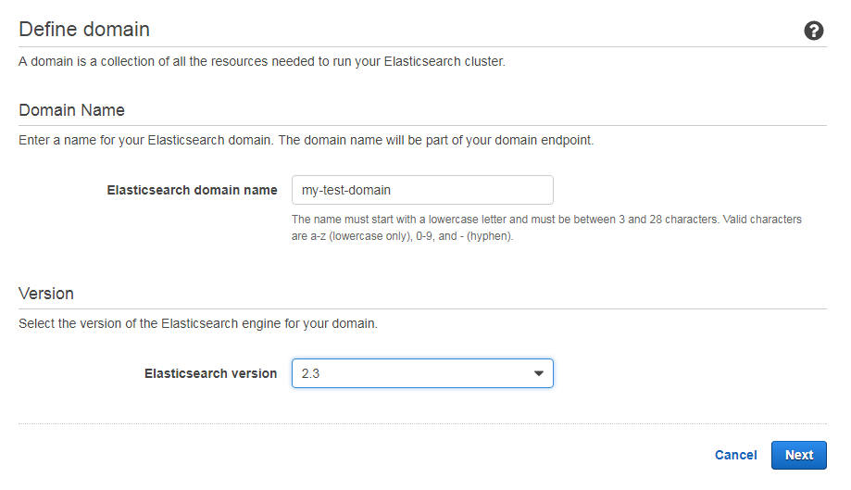

When you are setting up access policy there are many options.

For example if you choose **Allow or deny access to one or more AWS or IAM users**.

You must configure **AWS_ACCESS_KEY**, **AWS_SECRET_KEY**, **AWS_SERVICE**, and  **AWS_REGION** in local/run.sh, and set **AWS_SIGNING_ENABLED** as true.

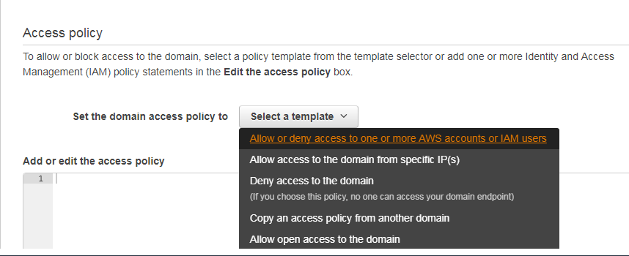

If you chose 'Allow open access to the domain', set AWS_SIGNING_ENABLED to false to disable the credential. Please been noted that this should be just for test purpose.

After you wait about 10 minutes to create domain successfully you can configure **ELASTIC_SEARCH_URL** to the endpoint below:

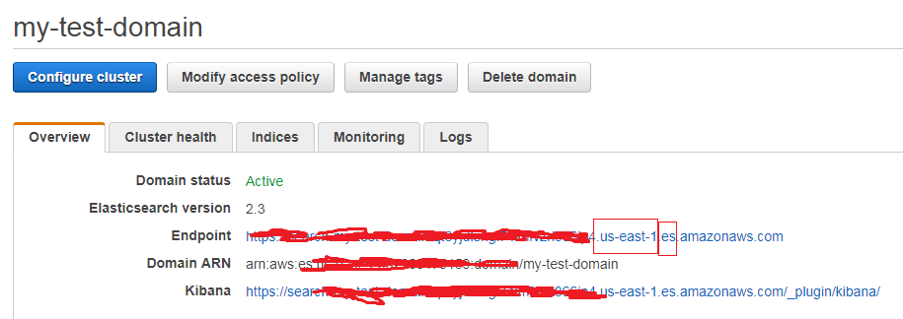

The **AWS_REGION** is us-east-1 and the **AWS_SERVICE** is es.

The direct app docker is https://github.com/appirio-tech/tc-common-tutorials/tree/master/docker/direct-app

Please follow the above url to configure and setup the tc direct app docker and online review docker.

For the elasticsearch, clone this branch: https://github.com/topcoder-platform/challenges-logstash-conf/tree/populate_more_challenge_info, configure and setup as Populate-Challenge-Submissions-in-ElasticSearch_verification.docx. Every time you change the data in the database, it's necessary to run one of the following two commands to update the elastic services:

docker-compose up challenges-feeder-initial-load

docker-compose up challenges-feeder

Please refer to the Populate-Challenge-Submissions-in-ElasticSearch_verification.docx for details

Then execute the following sql for the tcs_catalog database to make the users agree to all terms:

INSERT INTO user_terms_of_use_xref

SELECT u.user_id, t.terms_of_use_id, CURRENT, CURRENT

FROM user u

JOIN terms_of_use t ON 1=1

LEFT JOIN (SELECT user_id, terms_of_use_id FROM user_terms_of_use_xref) x

ON x.user_id = u.user_id AND x.terms_of_use_id = t.terms_of_use_id

WHERE x.user_id IS NULL;

The following sections just introduce the workflow of how to create a dev type challenge(assembly challenge) and move it to the final fix phase with the online-review system, the phase time for the challenge is not updated.

Go to https://cockpit.cloud.topcoder.com/direct and login as heffan/password, then click the Create Challenge

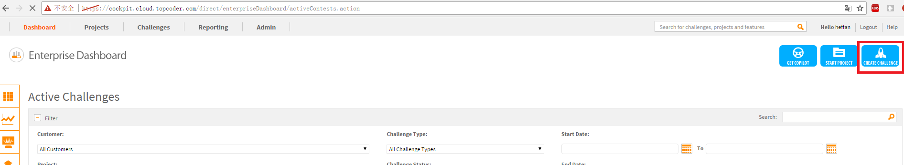

Then click the ADD NEW to create a new project.

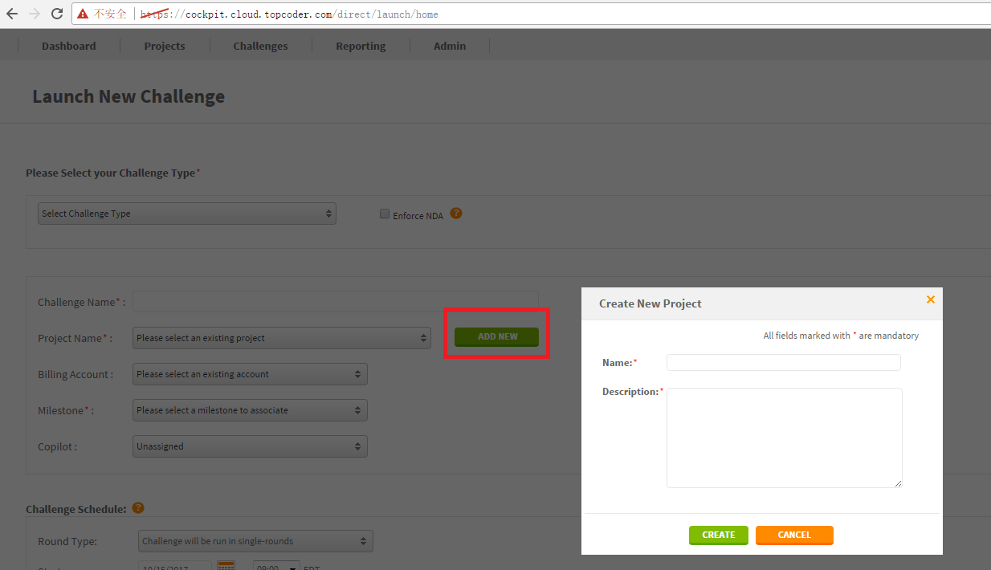

Click the Add Billing to project to add the billing:

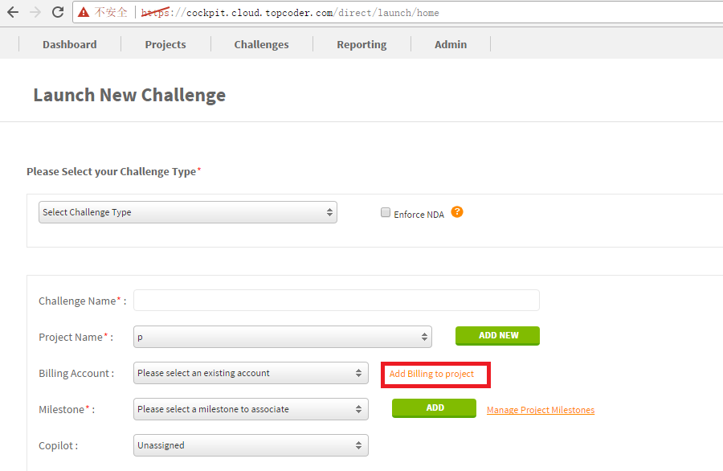

In the new page, select the project and click the ASSOCIATE BILLING BUTTON:

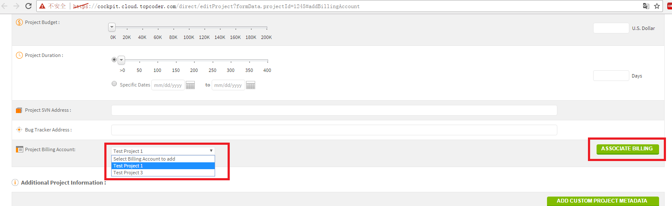

Then refresh the https://cockpit.cloud.topcoder.com/direct/launch/home again and add a milestone:

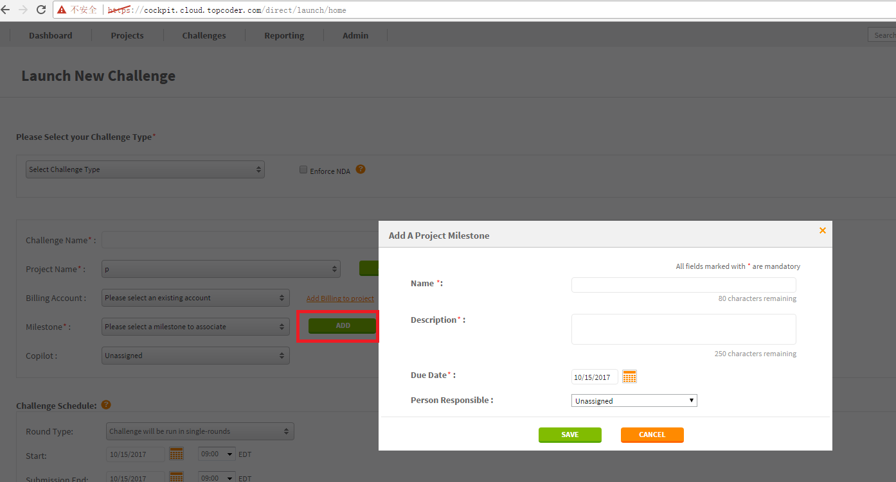

Then create an assembly challenge and fill any required data and click the continue button, please select the multi-rounds if you want the checkpoints phase.

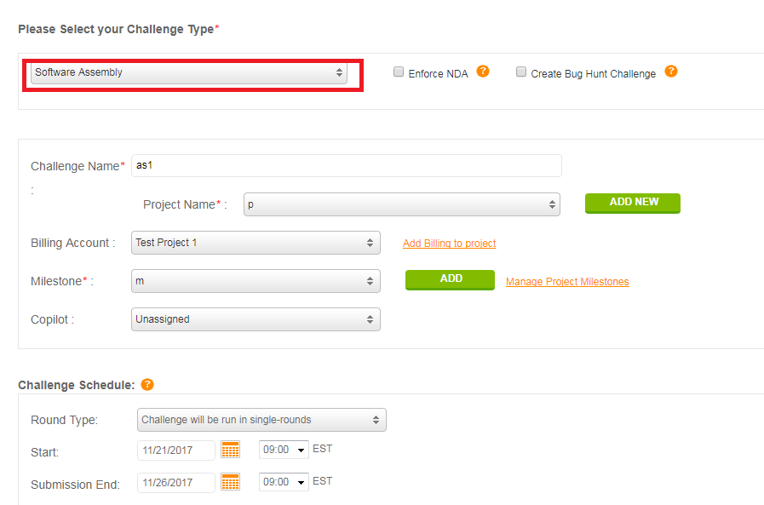

Finally click the submit button below:

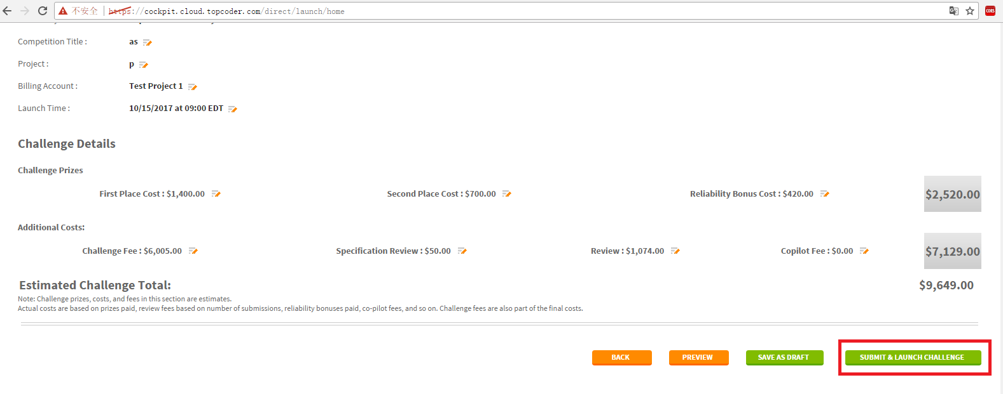

Click start the spec review now:

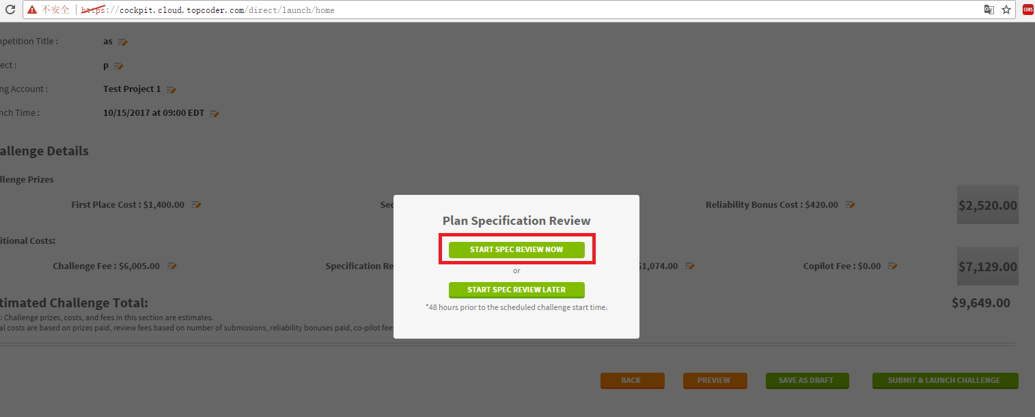

Then click the edit button:

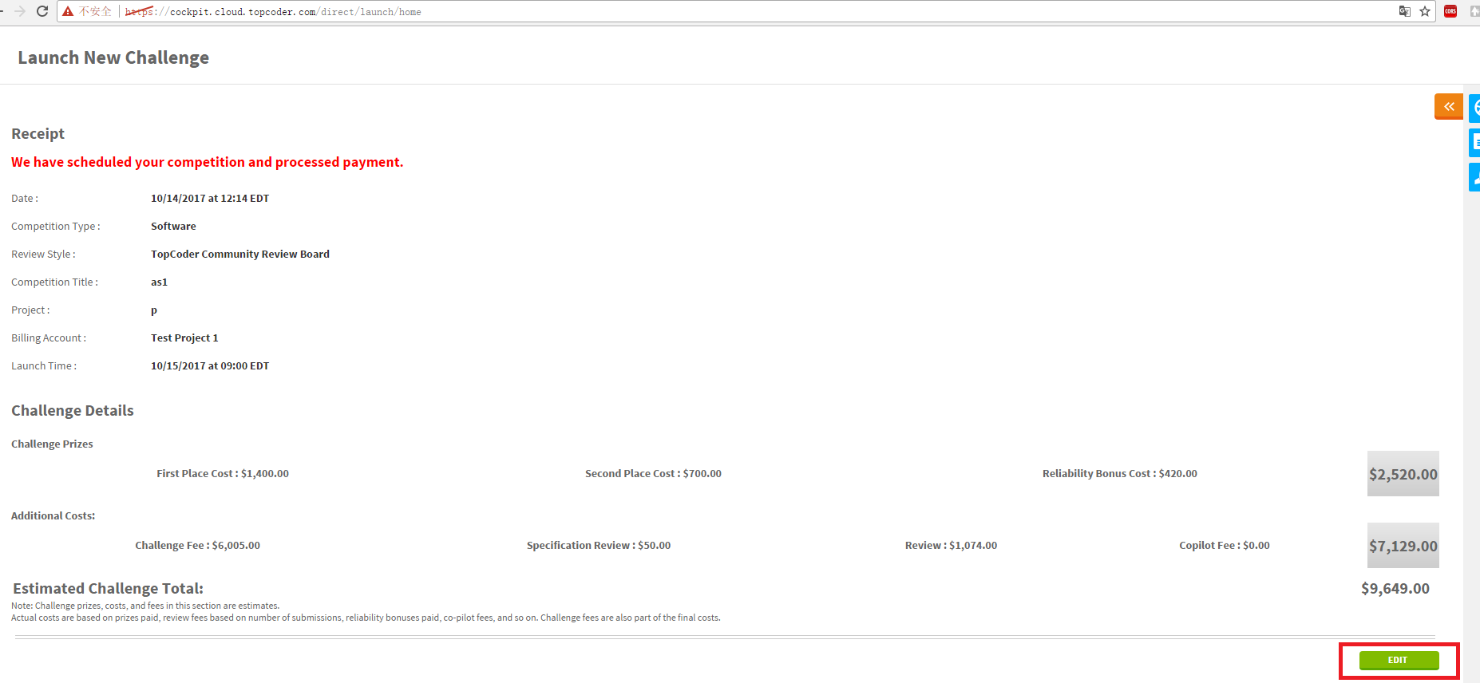

Then click the Online Review to go to the online review system

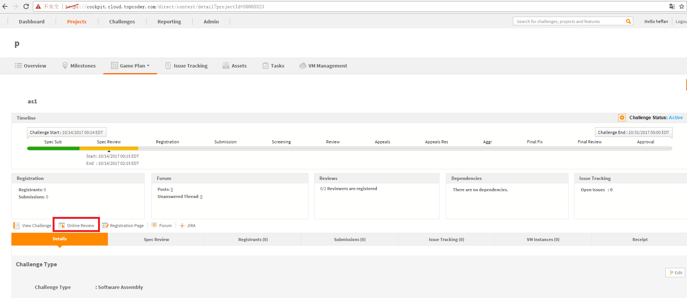

The url for the online review should be like http://tcs.cloud.topcoder.com/review/actions/ViewProjectDetails?pid=30005520

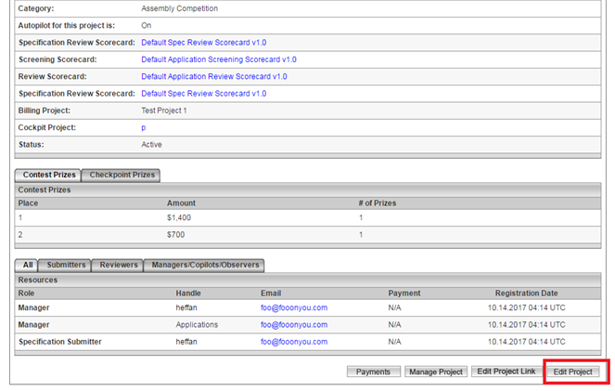

Then click the Edit Project button:

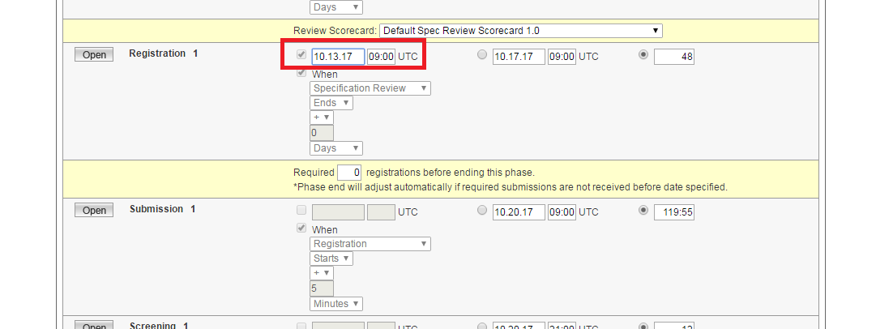

Edit the registration start date as above to open the registration phase(make the start date before the current date)

Then scroll down, add the forum id, and the spec reviewer, submitter and reviewers as following:

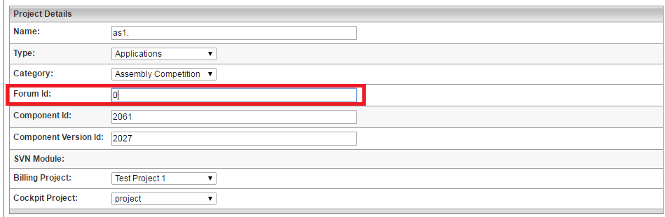

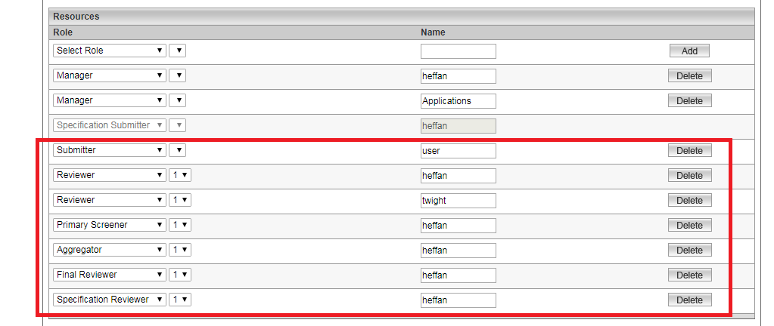

Then click the save changes button below, ignore the errors after save:

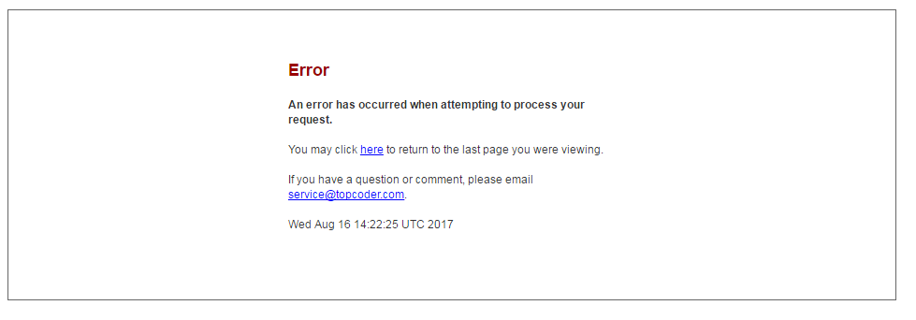

Then refresh the http://tcs.cloud.topcoder.com/review/actions/ViewProjectDetails?pid=30005520, there should be 'Specification Review' link.

Let heffan finish the spec review:

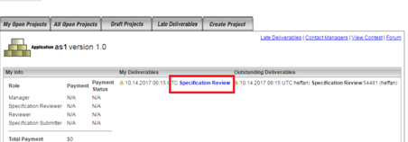

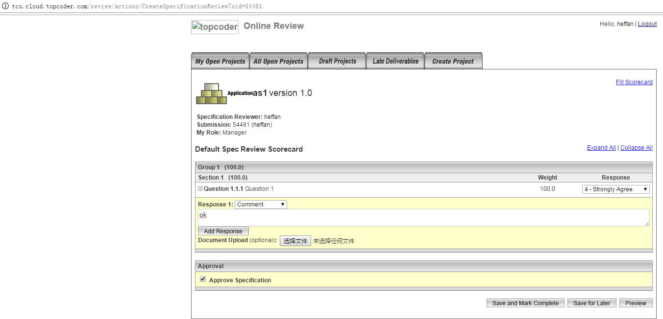

Then refresh the page http://tcs.cloud.topcoder.com/review/actions/ViewProjectDetails?pid=30005520 again, the registration phase should be started. Wait for about 5 minutes for the submission phase starts.

Then click the Logout button above and login as user/password

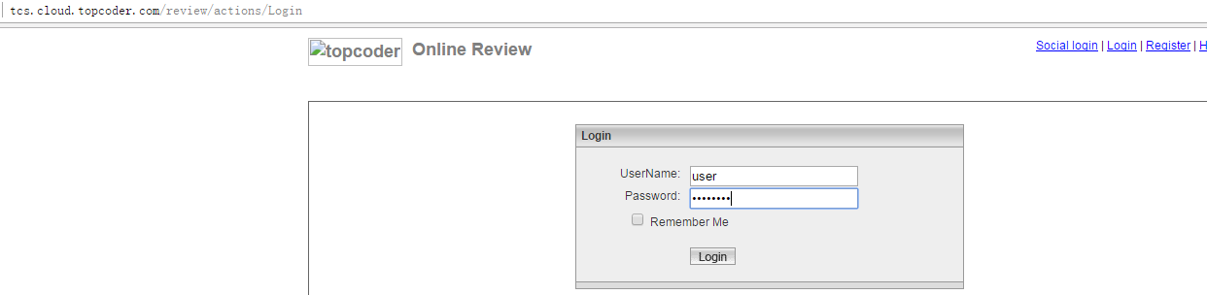

Then go to http://tcs.cloud.topcoder.com/review/actions/ViewProjectDetails?pid=30005520, and upload the submission:

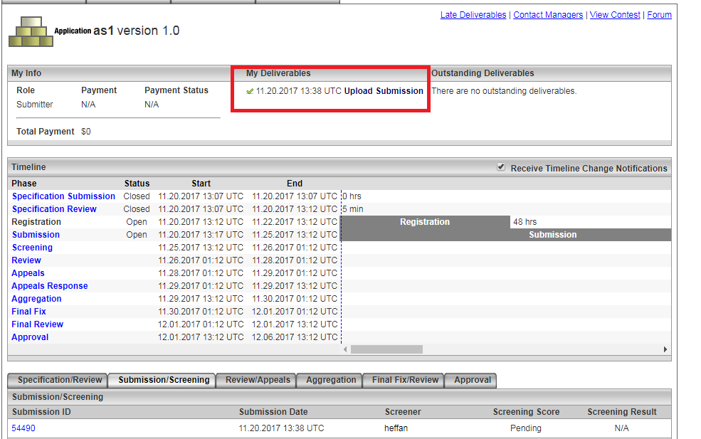

After user upload the submission, login as heffan, and go to the edit project page and set the submission duration phase to 0:01 to end the submission phase:

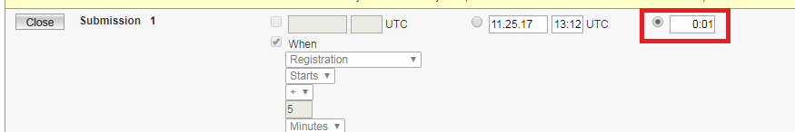

Let heffan finish the screening and review scorecards.

Login as twight and finish the review scorecards

Login as user and do some appeals and then complete the appeals.

Login as heffan to finish the appeal response.

Then move the project to aggregation phase and final fix phase.

You can also run the following sql for tc_catalog database to move the phase to final fix if the response phase is late or pending:

update project_phase set phase_status_id = 2 where project_id=30005520 and phase_type_id = 9;

update project_phase set phase_status_id = 3 where project_id=30005520 and phase_type_id < 9;

--Then login as user and let user upload final fix.

--Then attach the events:

insert into tcs_catalog:contest (contest_id, contest_name, event_id, modify_date) values (111111, 'test', 993, current);

insert into tcs_catalog:contest_project_xref (contest_id, project_id, create_date) values(111111, 30005520, current);

update tcs_catalog:project_info set value = 1000 where project_id = 30005520 and project_info_type_id = 30;

--Then set the groups:

delete from group_contest_eligibility where contest_eligibility_id in (1, 2);

delete from contest_eligibility where contest_eligibility_id in(1,2);

insert into contest_eligibility values (1, 30005520, 0);

insert into contest_eligibility values (2, 30005520, 0);

insert into group_contest_eligibility values(1, 10);

insert into group_contest_eligibility values(2, 14);

update security_groups set challenge_group_ind = 10 where group_id = 10;

update security_groups set challenge_group_ind = 14 where group_id = 14;

# Verify

Import the docs/ challenge-feeder.postman_collection.json

Push challenges

The id 30005520 is for assembly in the final fix. 30005523 is a code challenge in the registration phase.

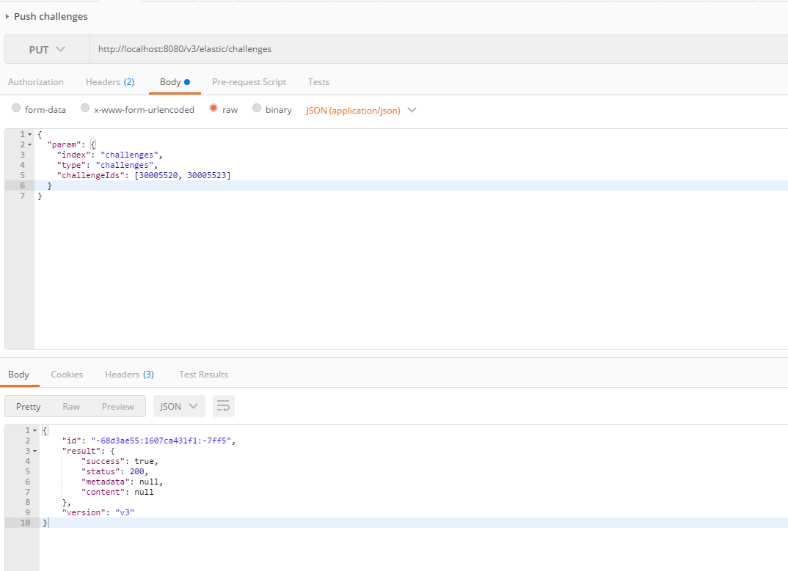

View challenge via ElasticSearch

Change the challenge id in the red rectangle.

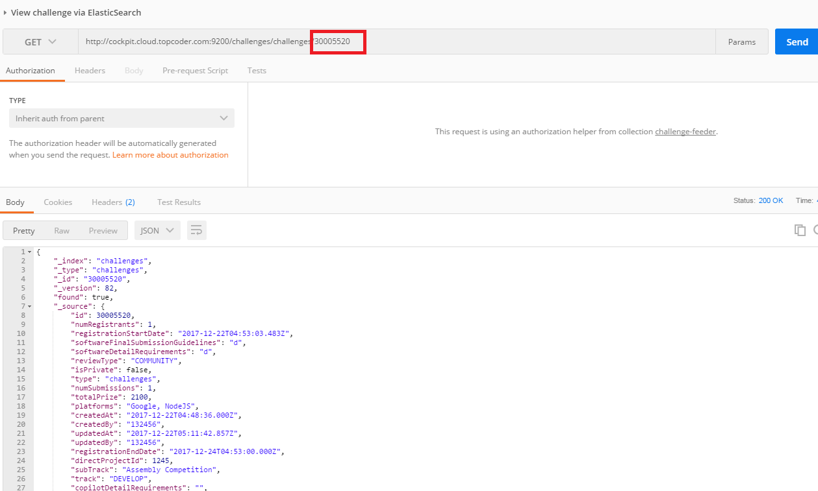

scroll down to check other fields:

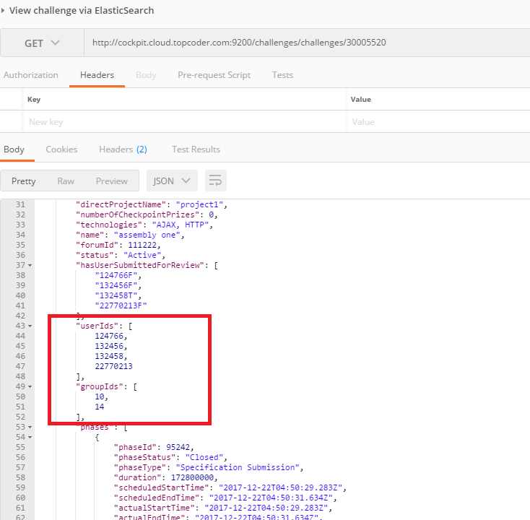

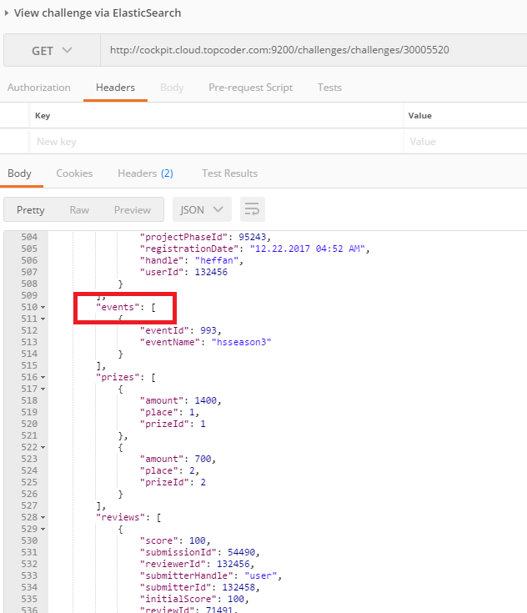

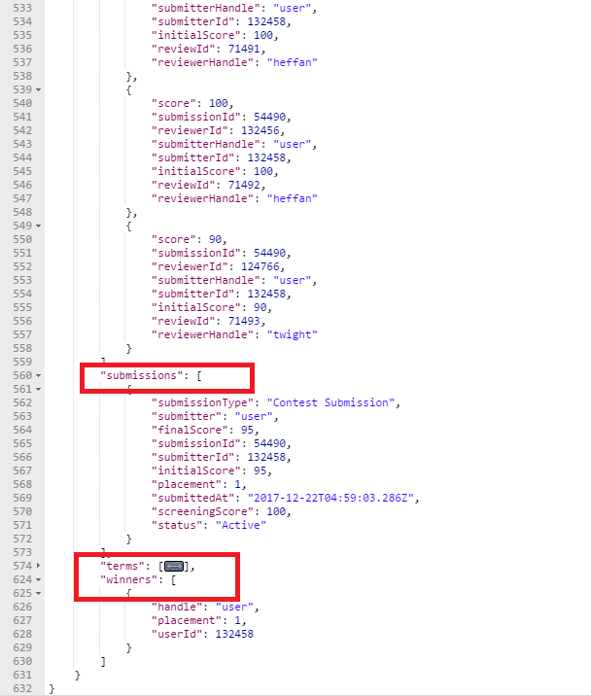

For the code challenge, check it in the same way. If you configure as push the data to the amazon service, change the http://cockpit.cloud.topcoder.com:9200 to https://search-your-url-xxxxx.us-east-1.es.amazonaws.com

For the design challenge, go to direct app and create a wireframe challenge:

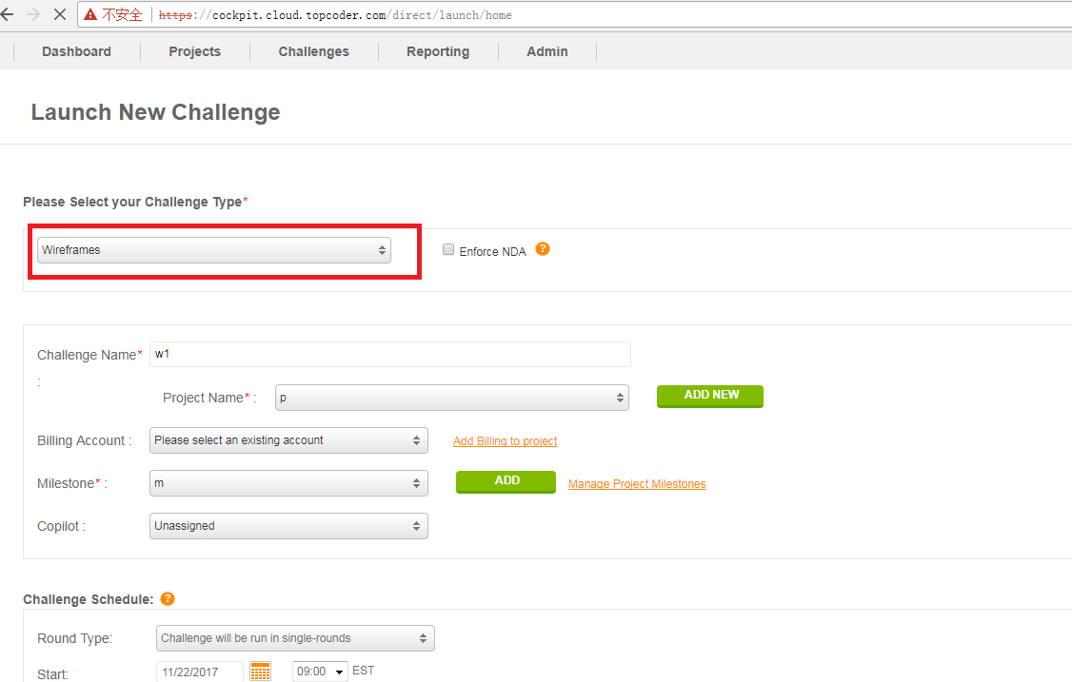

And fill the other fields and launch the challenge, assume that the challenge id is 30005522

In the online review, we can not upload the submission for the design(or studio) challenge, the upload submission link will be redirected to the url: http://studio.cloud.topcoder.com/?module=ViewContestDetails&ct=30005522

Hence we use the sql to add the submissions for the user, you just need to replace the 30005522 with the id you created below.

Select the tcs_catalog database and run the following sql.

--Run the sql to open the submission phase:

update project_phase set phase_status_id = 3 where project_id = 30005522 and phase_type_id in (1, 13, 14, 15, 16, 17);

update project_phase set phase_status_id = 2 where project_id = 30005522 and phase_type_id = 2;

--Run the sql to add the user as the submitter

insert into resource values(99026, 1, 30005522 , null, 132458, 132456, current, 132456, current);

insert into resource_info values(99026, 2, 'user', 132456, current, 132456, current);

insert into resource_info values(99026, 1, 132458, 132456, current, 132456, current);

--Run the sql to upload the submission for user:

insert into upload values(99031, 30005522 , (select project_phase_id from project_phase where project_id=30005522 and phase_type_id=2), 99026, 1, 1, 'xxx', null, 132458, current, 132458, current);

insert into submission values(99031, 99031, 1, null, null, null, null, 1, 132458, current, 132458, current, 1, null, null, null, null, null, null);

--add the heffan as the reviewer

insert into resource values(99225, 4, 30005522 , null, 132456, 132456, current, 132456, current);

insert into resource_info values(99225, 2, 'user', 132456, current, 132456, current);

insert into resource_info values(99225, 1, 132456, 132456, current, 132456, current);

-- move the project

update project_phase set phase_status_id = 2 where project_id=30005522 and phase_type_id = 11;

update project_phase set phase_status_id = 3 where project_id=30005522 and phase_type_id < 11;

--update the submission score

update submission set final_score = 100, placement=1, screening_score = 100, initial_score= 100 where upload_id in (select upload_id from upload where project_id in(30005522 ));

--run the following sql to init review data

insert into review (review_id, resource_id, submission_id, project_phase_id, scorecard_id, committed, score, initial_score, create_user, create_date, modify_user, modify_date)

values (90001, 99225, 99031, (select project_phase_id from project_phase where project_id = 30005522 and phase_status_id=2), 30000410, 1, 100, 100, 132456, current, 132456, current);

Then push the challenges:

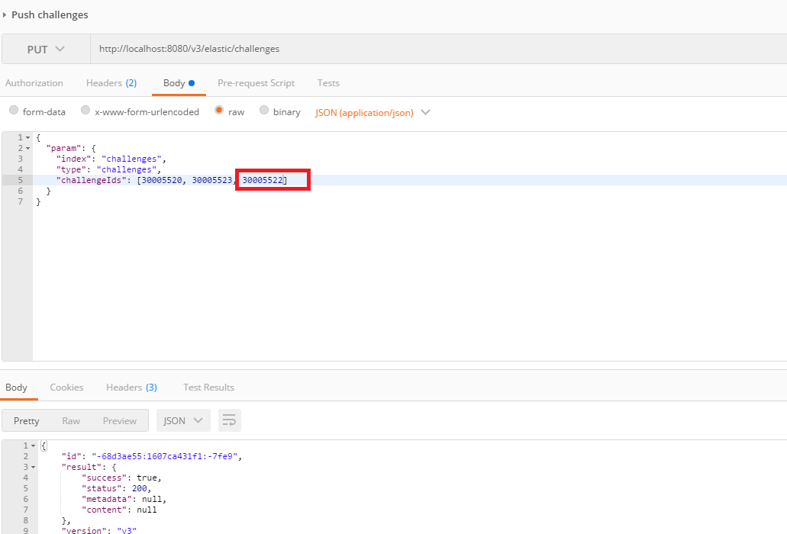

Check it in the elasticservice:

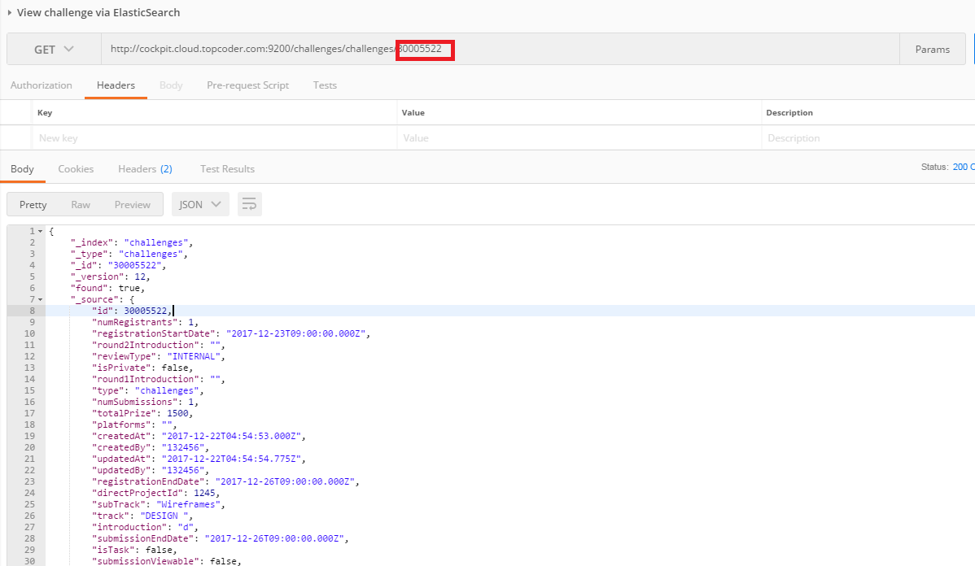

scroll down:

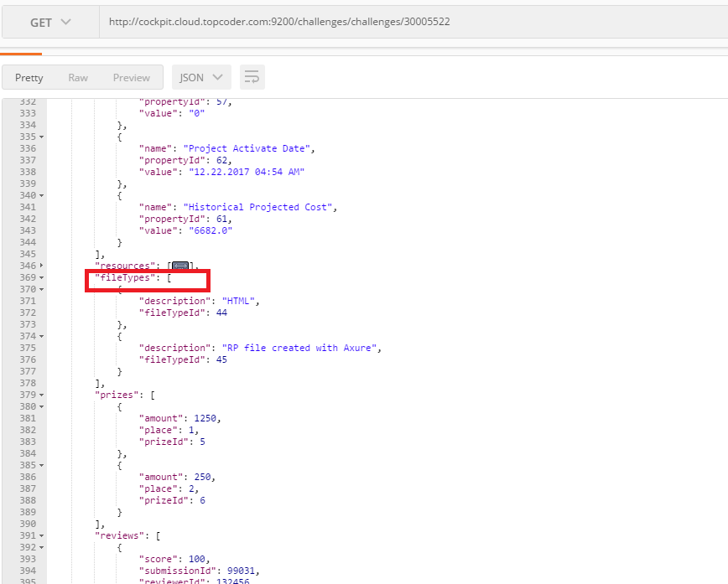

Then, you can run docker-compose up challenges-feeder-initial-load from the cloned challenges-logstash-conf to check that it pushes the same challenge data.

For other invalid request, check them in the same way.